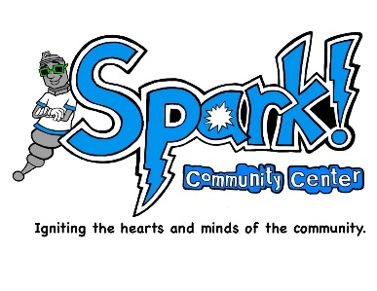

Spark! Community Center

59 Hanover Street, #4

Lebanon, NH 03766

603-678-8619

[www.sparkcommunitycenter.org](http://www.sparkcommunitycenter.org)

[info@sparkcommunitycenter.org](mailto:info@sparkcommunitycenter.org)

Volunteer Application

Full Name: ______________________________ Date: _______________

Full Address: _________________________________________________

____________________________________________________________

Permanent Address: ___________________________________________

____________________________________________________________

Mobile Phone: _______________ Home Phone: _____________________

Email Address: _______________________________________________

[ ] Yes, I wish to subscribe to the Spark! online Newsletter.

[ ] Yes, I wish to be included on Spark! email notifications for events, including donation

and volunteer opportunities.

*Date of Birth: ____________* Social Security Number: _______________

* *Background checks are performed for volunteers working directly with participants. You can disclose this later. if you choose.*

Statement of and description of prior criminal convictions or offenses:

Emergency contact: ___________________________________________

Relationship to applicant: _______________________________________

Address: ____________________________________________________

____________________________________________________________

Mobile Phone: __________________ Home Phone: __________________

Why would you like to volunteer at Spark! and what are your goals for this experience?

Please briefly summarize your previous work and volunteer experience (attach resume, if desired):

Please list any pertinent training, certifications, and specialized skills:

Volunteer skills and preferences -circle all that apply below:

Computer or IT support

Filing

Data entry

Typing

Phone calls

MS Word

MS Excel

Light cleaning

Heavy cleaning

Organizing

Event clean-up

Event planning

Fundraising

Grant writing

Marketing

Connecting socially

Food preparation

Cooking

Teaching classes-topics:

Group leader -topics:

Job skills support Aquaponics

Gardening

Arts and crafts

Handwork (knit, sew)

Music -instruments:

Games (cards, board games, video gaming, puzzles)

Outdoor games & sports

Billiards

Air hockey

Table tennis

Yoga, other movement Dance

Exercise

Support groups Language -please specify:

Anything else:

Do you prefer working independently or with a group?

Please tell us a little about your passions. How do you have fun and recharge?

Please list two references who can speak to your character and work ethic:

Name:______________________________________________________ Relationship:_________________________________________________ Phone:______________________________________________________

Name:______________________________________________________ Relationship:_________________________________________________ Phone:______________________________________________________

As Spark! reopens, operating hours are subject to change. (Currently it is Monday, Wednesday and Friday, from 12 p.m. -- 5 p.m., and Friday evenings until 7:30 p.m.)

Please fill in the times you are available next to each day:

Mondays

Wednesdays

Fridays

[ ] I am interested in learning more about Spark! Employment Opportunities as they arise.

Applicant Signature: _________________________ Date: ____________